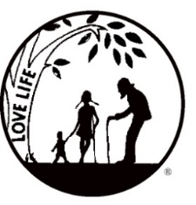
Presenting the Pro-Life Message in Southeastern Michigan Since 1970
Right to Life - LIFESPAN
Life is like an arch. If you discard one segment as worthless,
the span collapses — the value of all life brought low.
Please be sure to speak to your pastor and the editor of your church bulletin and ask them to include our May church notes.

www.miLIFESPAN.org
June 13, 2016
Hello, Everyone!
Wayne County pro-life volunteers are the best! We know that we have called upon many of you over the past couple of months for more than just a couple of mailings. The new Used Book Depository on Seven Mile and Merriman looks amazing because of the effort of so many people who gave of their time and talents. The Garage Sale went beautifully because of the many volunteers that came out. Thank you to all who are participating in our Father’s Day candy and pens this year! This fundraiser allows us to honor fathers while also spreading the message that LIFE is a gift.
Need additional copies of fliers? Please contact our office and we will happily make them for you! It is because of you and your commitment to LIFE, people find out about the many activities that LIFESPAN sponsors and learn about issues that impact LIFE, from conception until natural death.

UPCOMING EVENTS, we hope that you can participate in some, if not all:
- Our Pro-Life Breakfast will be held in October; watch for the exact date, speaker and location to be announced soon!
- We are trying to setup a Walk for Life for a Sunday in September. We are looking for volunteers willing to help out with planning and helping out on that Sunday. Call/email our office if you are interested.
- Beware of a current scam that is happening via phone. Look at the informational letter enclosed for additional information.
- Make sure that you share the July LIFESPAN Newsletter that contains the results of our candidate surveys. We want to make sure that everyone has the answers to questions about pro-life issues from candidates that are in your area. We know that you will be able to choose the candidates who best match your principles.
- Some new activities/fundraisers are in the works for Wayne County. Watch the newsletter and your church notes, as plans get finalized and the dates get set. We are very excited!

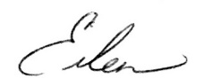
Yours in LIFE,
Please post fliers wherever possible and bring it to the attention of your pastor, youth group coordinators and pro-life groups.
Eileen Brandt
Director, Wayne County/Downriver Chapter

Main Office Oakland/Macomb Wayne County/Downriver
32540 Schoolcraft Road, Suite 100 1637 W. Big Beaver, Suite G 32540 Schoolcraft Rd., Suite 210
Livonia, MI 48150-4305 Troy, MI 48084-3540 Livonia, MI 48150-4305
email: mainoffice@rtl-lifespan.org email: oakmac@rtl-lifespan.org email: wcdr@rtl-lifespan.org
734-524-0162 Fax 734-524-0166 248-816-1546 Fax 248-816-9066 734-422-6230 Fax 734-422-8116

www.miLIFESPAN.org

