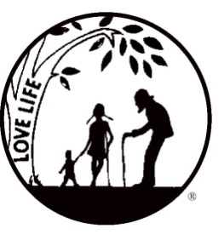
Right to Life-LIFESPAN Educational Fund
RESOURCE BOOK 2015
Advertising Contract

This book will contain pro-life informational material that will be used throughout the year. Your ad represents support for LIFESPAN’s educational efforts. Please fill out the form below and send it to us with your remittance included.
Deadline for submission is Friday, March 27, 2015.
Advertising Contract: I wish to publish ______________________ page ad for the sum of $_______________________.
Please run __________last year’s ad ______________enclosed, NEW ad
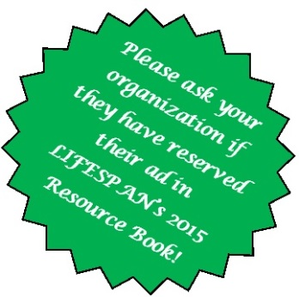
__________ EMAILED ad
Full page (7 x 10)
$280

Inside front cover
$325

Back cover (inside)
$325

Back cover (outside)
$525

1/4 page
(3.5 x 5)

$115
1/8 page
(3.5 x 2.5)
$65
Half page (7 x 5)
$165

• Due to the difficulty of working with various formats, we prefer to receive pdf files, at 300 dpi, all fonts embedded, sent by email to: editor@rtl-lifespan.org , indicating “LIFESPAN Resource Book Ad” in the subject line. In the case of electronic submissions, please send contract and check via post to the address below.
• You may also send a hard copy, camera-ready ad.
• If you are not able to submit camera-ready work, we will help you with your ad, just call us!
• Payment must accompany ad and contract.
• Advertisers will be sent a copy of the LIFESPAN Resource Book upon request only.
• LIFESPAN reserves the right to refuse any advertisement that it deems unsuitable.
A complimentary dinner ticket to the 2015 Annual LIFESPAN Dinner on Tuesday, May 5, 2015, will be given to any individual for every $200 worth of new ads obtained for LIFESPAN’s Resource Book. The ad seller’s signature must appear on the contract below when the ad and remittance is received by Right to Life - LIFESPAN Educational Fund.
Contact Person ____________________________________________________Phone (________)________________________
Name of Advertiser/Business__________________________________________Email_________________________________
Address___________________________________________________City________________________Zip________________
Ad Seller’s Signature _______________________________________________Phone (_______)_________________________
__________YES, please send me a copy of the 2015 LIFESPAN Resource Book.

Make checks payable and mail to:
Right to Life-LIFESPAN Educational Fund, 32540 Schoolcraft Rd., Ste. 100, Livonia, MI 48150-4305
For further information, call 734.524.0162 or email: mainoffice@rtl-lifespan.org

Contributions to Right to Life-LIFESPAN Educational Fund are deductible as charitable contributions for Federal Income Tax purposes.

